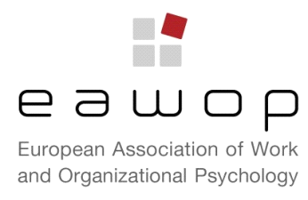

Report of the EAWOP Constituent Council (CC) meeting
MUNSTER, Wednesday 22 May 2013
EAWOP’s Executive Committee (EC) met Constituents’ representatives at the Münster Palace, room S-Festsaal, on Wednesday 22 May 2013, from 14.00 to 16.00. The following issues were discussed:

- The EAWOP president reported on the main activities of the Executive committee in the last two years. In particular, an update was given about the small group meetings, the summer school for early careers, the WorkLab, and Alliance related events. Finally, EAWOP future steps were outlined.
- The candidates for the Executive Committee positions present at the meeting introduced themselves. The procedures of the election and the number of vacancies were quickly refreshed.
- The representative of the Constituents in waiting from Greece and France introduced their association. A brief description also of the Slovenian constituent is given by the Chair.
- The Estonian representative presented their interest in developing a doctoral training centre, as, in this moment, in that country there is only one Ph.D. programme. The same interest is also shared by the Polish representative. Various ideas are presented and support shown for the programme. The experience of using concepts and tools of WOP in Finnish companies is also presented.
- The main steps and results of the pilot project on the Specialist certificate conducted in five countries is given. The report of the pilot and the updated proposal with all the requirements had been sent to Constituents before the CC. A roundtable with all the members of the committee that supervised the project, held during the conference, is announced.
- The next issue of the “In Practice journal” has been published and notification was sent to all members and Constituents. Constituents were solicited to present proposals of papers or items.
- EAWOP aims to create a group of expert that can act as consulting body both for EAWOP and also for EFPA. Procedures to set up this body are in process.
- Considering some difficulties experienced by the British constituent in finalising the proposal for the 2017 conference, a letter of interest was sent to the EAWOP General Secretary by the Italian Constituents. This letter expresses interest in considering the possibility to have the 2017 conference in Italy.
- The next Constituent Council meeting will be held in May 2014 in Oslo, in order to visit the new conference venue. The date will be communicated in due time and will be posted on the Constituent activities on the web site.

